
QUALITY ALERT

Customer: ChamClad Date: January 25, 2024
Die: 15766 Color: ALL
Type of Complaint: ChamClad REJECT Customer NCR:

Description: ChamClad REJECTED – Material has skinny wall and out of SHAPE.

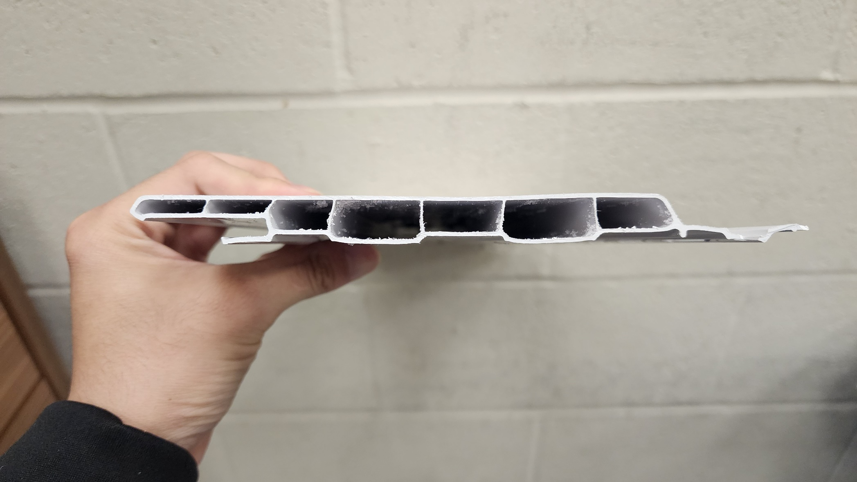

PLEASE CHECK CAREFULLY AND
MAKE SURE BAD MATERIAL NOT PACK INTO BUGGY

BY SIGNING BELOW, YOU ACKNOWLEDGE THE PROBLEM ABOVE AND AGREE TO MONITOR THIS ISSUE IN FUTURE PRODUCTION RUNS.
DAY SHIFT |  | AFTERNOON SHIFT |  | NIGHT SHIFT
NAME | SIGNATURE | NAME | SIGNATURE | NAME | SIGNATURE

